Northern Beaches Watercolour
Painting Classes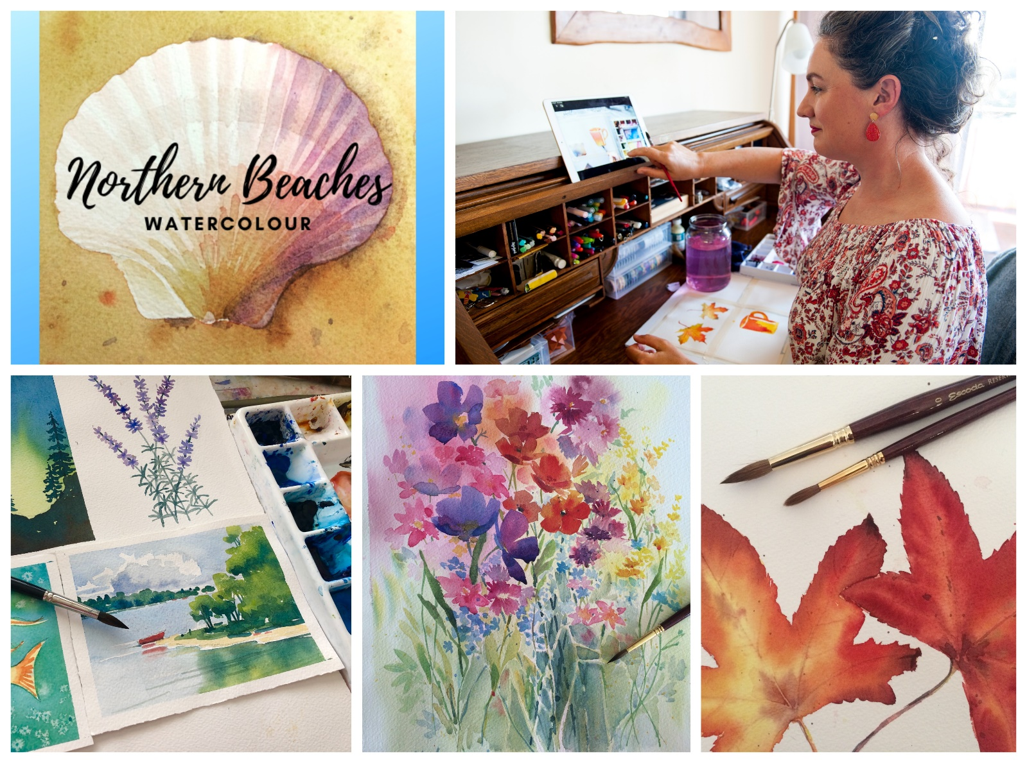
website – www.northernbeacheswatercolour.com.au
email: northernbeacheswatercolour@outlook.com.au
Online – Anytime OR Live On Zoom
From Absolute Beginners to Intermediate
Join from ANYWHERE in Australia.
no experience necessary.
Full Demonstrations * Class notes * Everything explained
Online at your own pace, or join a great fun class.

